**Course Methods Year 11**

Student name: ________________________ Teacher name: ________________

Date: 17/02/20

**Task type: Response**

**Time allowed for this task: 40 mins**

**Number of questions: ___________**

**Materials required:** NO CALCULATOR REQUIRED

Standard items: Pens (blue/black preferred), pencils (including coloured), sharpener, correction fluid/tape, eraser, ruler, highlighters

Special items: Drawing instruments, templates, notes on one unfolded sheet of   
A4 paper, and up to three calculators approved for use in the WACE examinations

**Marks available: ___36___ marks**

**Task weighting: ____%**

**Formula sheet provided: Yes**

**Note: All part questions worth more than 2 marks require working to obtain full marks.**

**Question 1 (1.1.6) (2, 2 = 4 marks)**

Solve each of the following for $x$*.*

$2x-3=11-5x$

$10-2x=\frac{2x}{3}$

**Question 2 (1.1.4, 11.5, 1.1.6) (2, 2, 2, 3 = 9 marks)**

Determine the equation of a line that passes through the point $(-4, 6)$ and:

1. has a gradient of 3
2. passes through the point $\left(2, 5\right).$
3. is parallel to the line $2y-4x=-7$.
4. is perpendicular to the line $2y-x-8=0.$

**Question 3 (1.1.1, 1.1.5, 1.1.6) (4, 2, 2 = 8 marks)**

The coordinates $P(2,p)$ and $Q(q+1, 3q-2)$ both lie on the line $y=5x+1$.

1. Find:
2. the values of $p$ and $q$.
3. the midpoint of $PQ$.
4. For what value of $m$ does the line $y=mx+2$ not intersect with the line $y=5x+1$? Justify your answer.

**Question 4 (1.1.4, 1.1.5) (2, 1, 1, 2, 1 = 7 marks)**

The graph below shows cost, $C$, in dollars versus distance $x$, in kilometres, for two different car rental companies A and B. (Assume that parts of distance are charged for proportionately.)

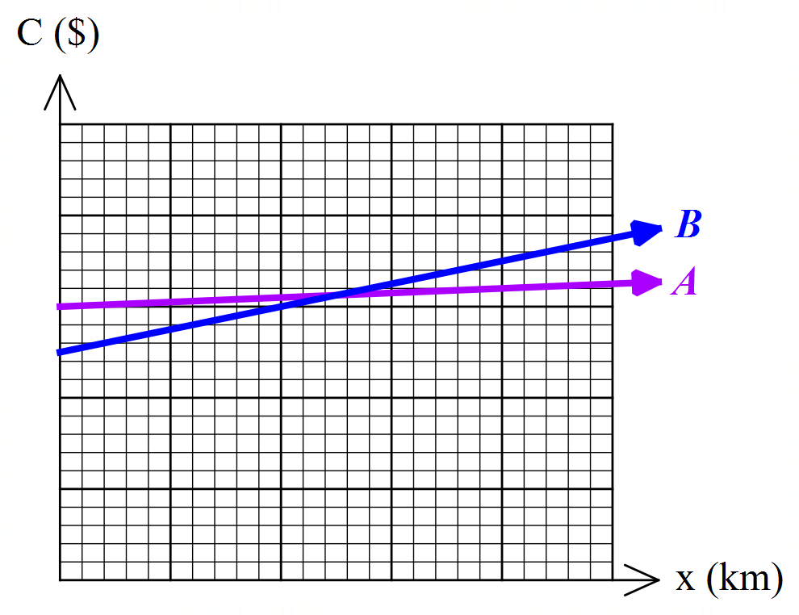

The costs for each company are outlined in the table below.

1. Match each cost model to each company by completing the table below.

|  |  |
| --- | --- |
| $$C=250+0.25x$$ | $$C=300+0.05x$$ |
|  |  |

1. Explain what the gradient in the equation $C=250+0.25x$ represents.
2. Construct a linear rule for $y=C_{A}-C_{B}$, the difference in cost between Company $A$ and Company $B$.
3. Sketch the equation from part c) on the graph below clearly showing all intercepts.

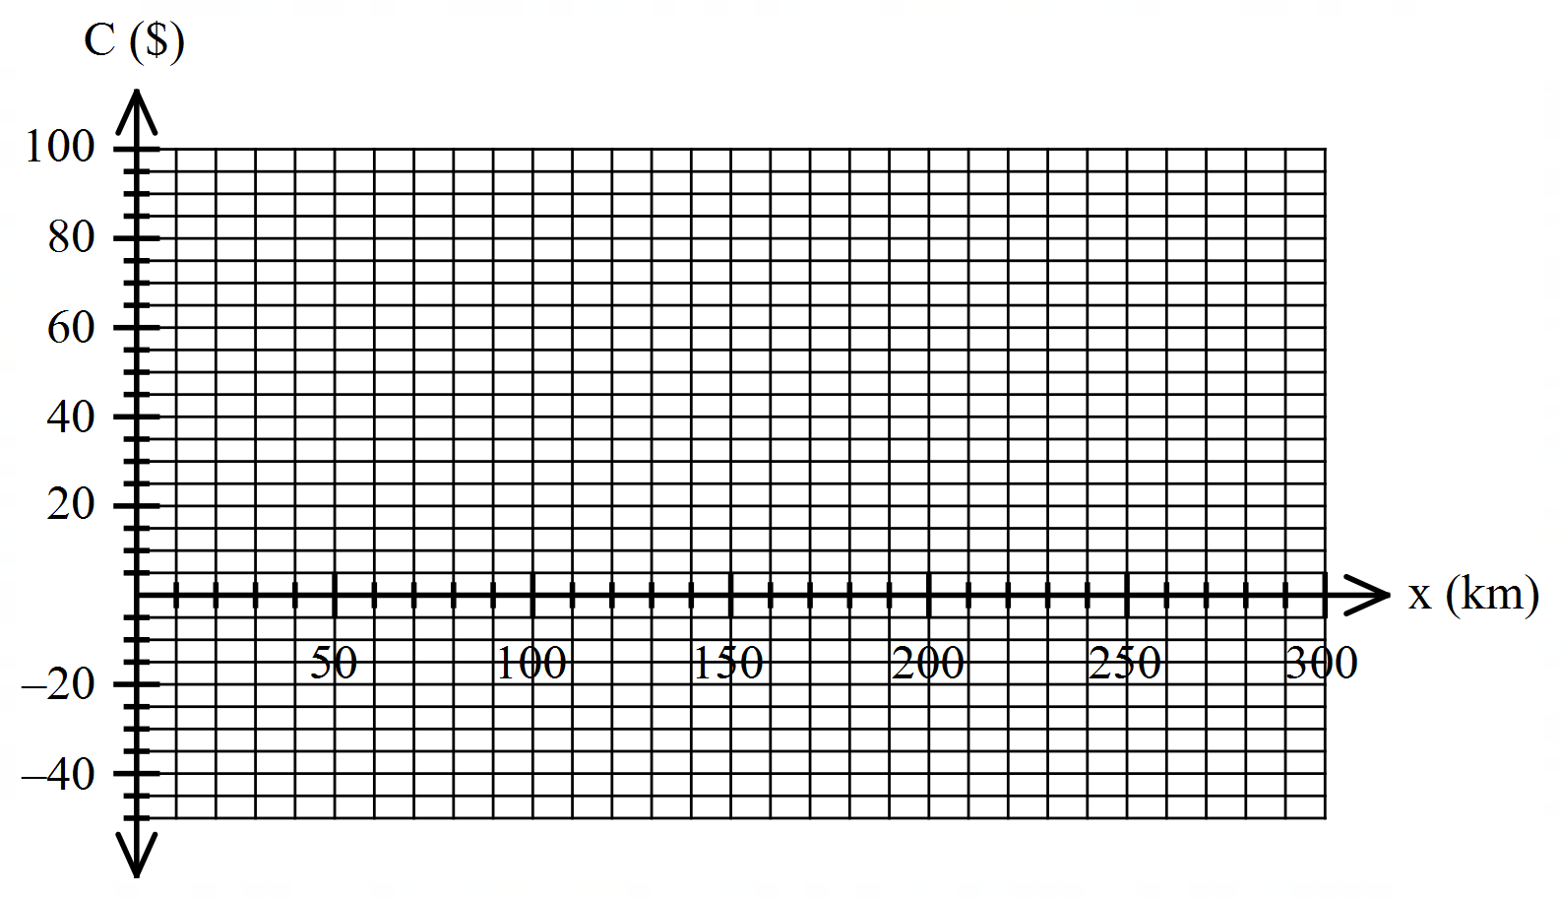

1. Using the graph in part d) determine the number of km when the costs of Company $A$ is cheaper than those of Company $B$.

**Question 5 (1.1.6) (4 marks)**

Solve for $x$ and simplify your answer if possible.

$\frac{x+a}{b}=\frac{b-x}{a}$

**Question 6 (1.1.6) (3, 1 = 4 marks)**

A car travelling at $60 km/h$ takes $t$ hours to go from $A$ to $B$. If the speed of the car is reduced by $10 km/h$, the time to go from $A$ to $B$ is increased by half an hour.

1. Calculate the value of $t$.
2. Hence, find the distance between $A$ and $B$.